A Brief History of Taekwondo
By Ronald A. Southwick
The name Taekwondo is derived from the Korean word "Tae" meaning foot, "Kwon" meaning fist and "Do" meaning way of. So, literally Taekwondo means "the way of the foot and fist". The name Taekwondo, however, has only been used since 1955 while the arts' roots began 2,300 years ago in Korea. Known as a martial art and way of life, the evolution of Taekwondo was a direct result of the happenings in Korea long ago, and knowledge of the history is an important step in understanding Taekwondo.
Early Korea:
Korean history began when in 2333 B.C. the legendary national founder, Tangun, founded "Old Korea" at Asadal. As in the histories of other nations, communal life was gradually transformed into tribal communities, and then tribal leagues and finally took the form of a state. Although no written history of the fighting systems of this time remains it is known that the people of this time were hunters and had some means of protection as well as livelihood.
The Three Kingdoms:
During the 6th century A.D. what we now call the Korean peninsula was divided into three kingdoms; Koguryo, Paekje and Silla. 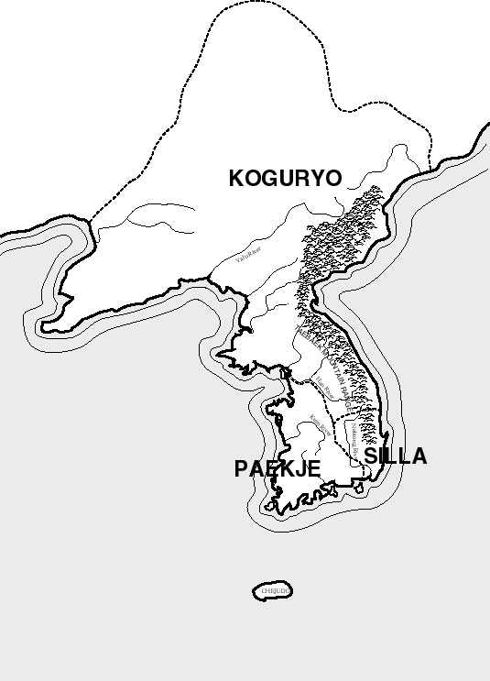

Koguryo (37 B.C.- 668 A.D.)- Koguryo was the largest kingdom. It occupied the southern section of Manchuria and the northern section of the Korean peninsula. Paekje (18 B.C. - 600 A.D.)- Paekje was situated along the Han River and in southwestern Korea. Silla (57 B.C.- 936 A.D.)- Silla was the last, and smallest of the kingdoms and located on the southeastern tip of the Korean peninsula. Archeological findings during these times such as the mural paintings on the royal tombs during the Koguryo period, stone sculptures at pagodas during the Silla period and documents written in the Paekje period, show techniques and fighting stances that were probably the first forms of Taekwondo.
The three kingdoms were at war with each other and constantly fought for new ground on the peninsula. Silla, being the smallest and weakest militarily began to have a difficult time protecting itself against the other kingdoms and so took an action which would turn out to be a key point in Korean history.
HwaRang:
The 24th king of Silla, Chin Heung, formed a group of warriors, which were called the HwaRang. The HwaRang were trained in weapons such as the sword, spear and bow. They devoted their lives to these martial skills in the hopes that they could save Silla. The HwaRang also studied an unarmed form of combat called SooBak. SooBak was a primitive form of foot fighting, using some hand, but mostly foot techniques. The HwaRang took SooBak and added things to it to create a more fighting art. The techniques of SooBak were created to be used in fighting along with the other weapons of the HwaRang to make the warriors able to defeat their enemies. But, Chin Heung needed something more than just competent soldiers; he needed something to unify the HwaRang and create the mental conditioning to lead the kingdom to victory. So, he asked Won Kang, a Buddhist monk and scholar, to take charge of the HwaRang training. Won Kang did so and not only created fine warriors, but actually a way of thought for the HwaRang. Won Kang came up with a code of ethics that the HwaRang warriors followed. They were:

1. Be loyal to your king
2. Be obedient to your parents
3. Have honor and faith among friends
4. Have perseverance in battle
5. Justice never to take a life without cause

With a the code of ethics and with their skills in fighting the HwaRang became the HwaRangDo, which meant "way of the flower of manhood." The HwaRangDo became known for their bravery and fighting skill and soon supplied the leadership to defeat both the Paekje and Koguryo kingdoms and unify Korea in to one country known then as Koryo.
Koryo Dynasty: (918 A.D. to 1392)
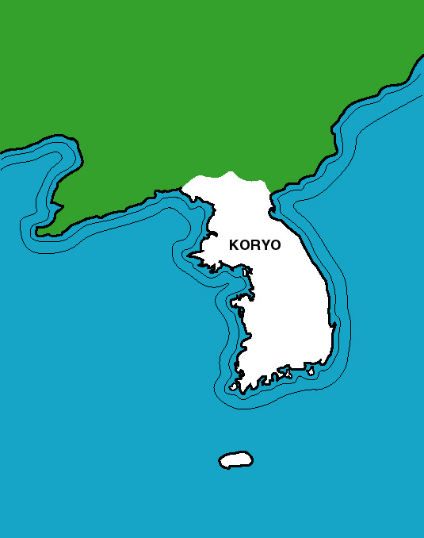
The Koryo Dynasty was a time for growth and development in the martial arts. During this time unarmed combat gained its greatest popularity. It was believed that SooBak was introduced to China and became known there as KwonPup. SooBak also changed its name to SooBakGi because of the new techniques and the mental discipline added to the style. SooBakGi became a popular sport by both the military and the general public. Martial arts were on an upswing and even new styles began to appear. One such style was Tae Kyon. Tae Kyon involved many more and new kicking techniques and was designed as more of a fighting sport than a discipline. Tae Kyon and SooBakGi contests were held at annual festivals given by the king. The winners of this contest were given high court offices and also taught the styles to the military, which now made these unarmed arts mandatory. Since the soldiers learned and practiced these arts, during their travels though out the kingdom they also spread the study of martial arts.

Yi Dynasty (1392 A.D. to 1910):
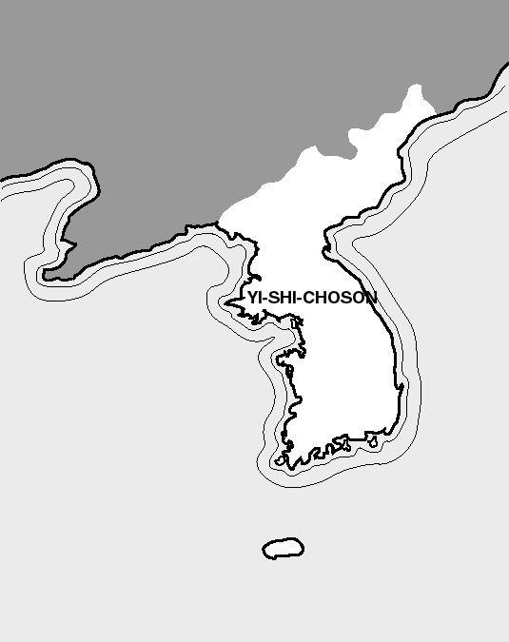
During the Yi Dynasty, Korea (Yi-shi-Choson) underwent a dramatic change from Buddhism, the predominate religion, to Confucianism. This change brought a Chinese influence over the government and the people of the time. Military leaders began to lose their power to civilian statesmen who believed in the cultural development of their civilization. The people as a whole began to lose interest in the study of martial arts. The study of martial arts, including weapons, was banned to all but the military. The HwaRangDo, which were rooted in the Buddhist teachings, gradually lost its importance among young people. Martial arts began a great downfall. There was, however, an important contribution to the martial arts when King Jong Jo ordered a manual of military arts to be written, including weapons, Tae Kyon and SooBakGi. The manual, written by Lee Duk Mu, included detailed sections on unarmed combat thus preserving in writing the techniques of these fighting arts. During the Yi Dynasty several invasions by the Japanese were fought off. However, due to the eventual decline of military power, the Yi Dynasty ended with the Japanese takeover on August 2, 1910.
Japanese Control:
Now that Japan had great influence in Korea (Choson) many things were changed. All competitive sports and martial arts were outlawed. Only the military, now under Japanese control, could practice martial arts. SooBakGi was practiced in secret and soon changed its name again to SooBakDo. Japanese combat arts were introduced to Korea at this time. The people of Korea received them with great interest. Due to peace treaties between the Japanese and Koreans, Japanese educational curricula were taught in all Korean schools and also such Japanese arts as Kendo ("way of the sword"), Judo, Karate, and Aikido. Once again martial arts began to flourish with each side, Japan and Korea, trading techniques and styles of martial arts. On August 15, 1945 Korea was liberated from Japan and Korean arts could once again develop.
Unifying of Taekwondo:
Within Korea there were five major martial art academies or Kwans. They were called Mooduk Kwan, Jido Kwan, Changmu Kwan, Chungdo Kwan, and Songmu Kwan. Within these schools lie a variety of styles such as KongSooDo, Tae Kyon, SooBakDo, TangSooDo, KwonPup, etc. The way of teaching and employing many of the techniques varied as much as the schools and in 1946 an attempt was made to unify Dojangs (training halls) and standardize instructional methods. Some of the leaders wanted to uphold the martial art character of the schools while others wished to create a combat sport. These meetings met with no success.
In 1955 a board of instructors, historians and prominent society members sat down to coordinate all the schools and select a name for the hopefully unified art. In April 1955 a new name was from a group of names by the board, it was Taekwondo.
In 1962 the Korean Amateur Sports Association recognized the Korean Taekwondo Union, which later became known as the Korean Taekwondo Association (K.T.A.).

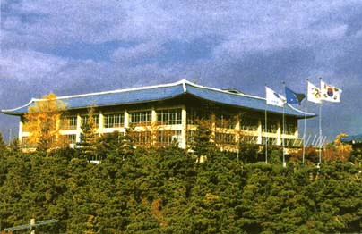
On May 28, 1973 the World Taekwondo Federation was officially established at the Kukkiwon (headquarters) by Dr. Un Yon Kim. Located in Seoul, Korea the World Taekwondo Federation is the governing body which preserves Taekwondo's roots and development, controls testing and testing requirements, and promotes the study of Taekwondo all over the world. In this way the WTF hopes to continue the unification of their native art.

Taekwondo Today:
Taekwondo today is just as exciting as ever. Taekwondo, under the leadership of the World Taekwondo Federation has grown into an international art and sport practiced in over 190 counties worldwide.
In 1975 the U.S. Amateur Athletes Union (AAU) accepted Taekwondo as an official sport. Taekwondo was also admitted to the General Association of International Sports Federations (GAISF) and the International Council of Military Sports (CISM) in 1976. In 1980 the WTF became an International Olympic Committee (IOC) recognized sports federation, making Taekwondo a demonstration sport for the 1988 and 1992 Olympic Games. Taekwondo is now an official event for the 2000 Olympiad to be held in Australia.
In the United States there are more than 5million practitioners of this Korean art. The United States Taekwondo Union (USTU) is the only National Governing Body for the sport of Taekwondo in the United States. As the NGB for the sport, the USTU is a member of the United States Olympic Committee, The World Taekwondo Federation and the Pan American Taekwondo Union.
© r.southwick 1998
spock@msu.edu

